St Gregory’s Ride
Sunday 27th May 2018
Come and join a pleasure ride with spectacular scenery in the foothills of the Cheviots
Approx 8.5 miles, includes a few optional jumps
(shorter route also avaiable)
Start anytime between 10am and 1pm
Location: Sandyhouse, Milfield NE71 6TJ
Horseboxes enter from Milfield - A697 (Opp Red Lion)
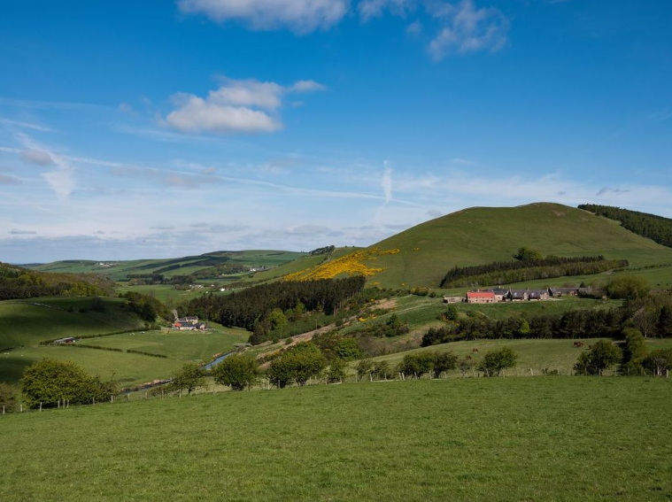
£20 pp, for further information contact:
George Halliday on 07801 245064 or kl78hal@gmail.com

